Chapter R

- Perform indicated operations. Express your answer as a single polynomial in standard form. Determine its degree and give the value of its leading coefficient

$(4x−1)(4x+1)−2(2x^{2}−3x+1)$
- Find the quotient and the remainder when $3x^{4}−5x^{3}+2x−4$ is divided by $x^{2}+3$.
- Factor completely each polynomial. If the polynomial cannot be factored, say it is prime.
a) $\text{27}−3x^{2}$
b) $2x^{5}+\text{16}x^{2}$
c) $x^{3}+8x^{2}−\text{20}x$
d) $2x^{2}+5x−3$
e) $2(3x+4)^{2}+(2x+3)⋅2(3x+4)⋅3$
4. Perform indicated operations and simplify the result. Leave your answer in factored form.
a) $\frac{x^{2}−3x−\text{10}}{x^{2}+2x−\text{35}}⋅\frac{\text{21}−4x−x^{2}}{x^{2}+9x+\text{14}}$
b) $\frac{\frac{2x^{2}−x−\text{28}}{3x^{2}−x−2}}{\frac{x^{2}−3x−4}{x^{2}+2x−3}}$
c) $\frac{x+4}{x^{2}−x−2}−\frac{2x+3}{x^{2}+2x−8}$
d) $\frac{2+\frac{1}{x}}{4x−\frac{1}{x}}$
5. Simplify each expression. Express your answer so that only positive exponents occur. Assume that the variables are all positive.
a) $\frac{4x^{−2}(\text{yz})^{−1}}{2^{3}x^{4}y}$
b) $(\text{xy})^{\frac{1}{4}}(x^{−2}y^{2})^{\frac{1}{2}}$
6. Write the expression as a single quotient in which only positive exponents and/or radicals appear. Assume x > -1.
$\frac{\sqrt{1+x}−x⋅\frac{1}{2\sqrt{1+x}}}{1+x}$

7. Factor the expression. Express your answer so that only positive exponents occur.
$3(x^{2}+4)^{4/3}+x⋅4(x^{2}+4)^{1/3}⋅2x$
8. Simplify each expression. Assume all variables are positive
a) $\sqrt{\frac{x^{5}y^{6}}{4z^{3}}}$
b) $\sqrt[3]{\text{27}x^{4}y^{\text{12}}}$
9. Rationalize the denominator of each expression
a) $\frac{3}{2\sqrt{5}}$
b) $\frac{2\sqrt{3}−4}{\sqrt{3}+1}$

Chapter 2

10. Given two points A = (-1,0) and B = (2,4). Find
a) the exact distance between A and B
b) the midpoint of the line segment joining A and B
11. The graph of an equation is given below. List the x- and y-intercepts of the graph.
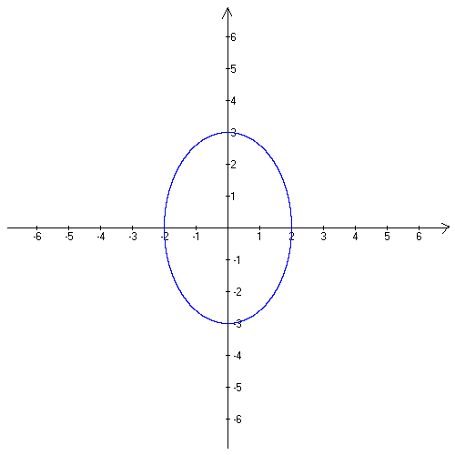
12. Find the intercepts of the graph of the equation y² = x² + 5x + 4
13. Based on the graph given below, determine whether it is symmetric with respect to the x-axis, the y-axis, and/or origin.
a) b) c) d)
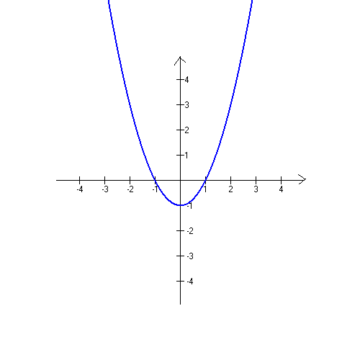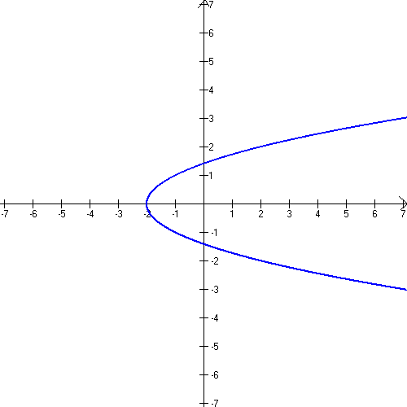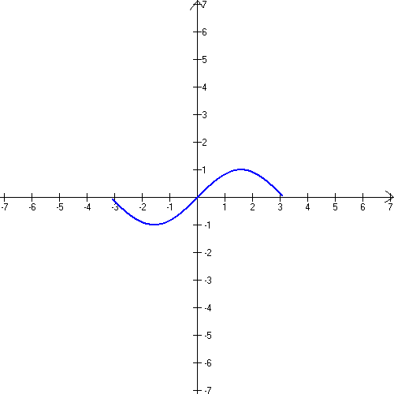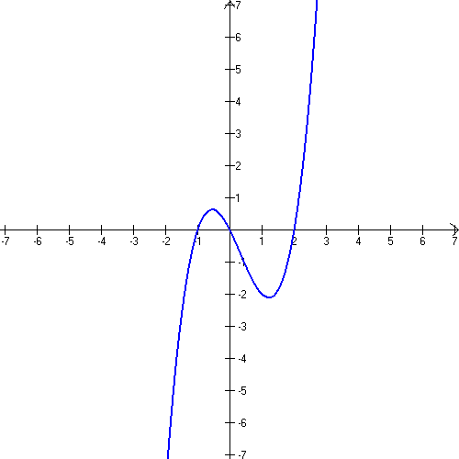
14. Test the equation for symmetry
a) $y=\frac{x^{2}−3}{2x^{3}}$
b) $y=2x^{2}−3x+1$
15. Write the standard form of the equation of the circle with center at C = (2,-3) and radius r = 4.
16. Find the center and the radius of a circle given by the equation $x^{2}+y^{2}−6x+8y−2=0$
17. Find the slope of the line passing through the points (-2,3) and (-1, -4).
18. Graph the line containing the point P = (-1,2) and having the slope $m=−\frac{2}{3}$. Write the equation of this line in the slope-intercept form.
19. Find the slope and y-intercept of the line given by the equation -x + 3y = 6.
20. Find an equation of the line with the given properties. Express your answer in the slope intercept form
a) containing the points (-1, 0) and ( 2,4)
b) vertical; containing the point (6, -3)
c) horizontal; containing the point (-1, 5)
d) slope undefined; containing the point (2,4)
21. Find the equation of each line
a) b) c)
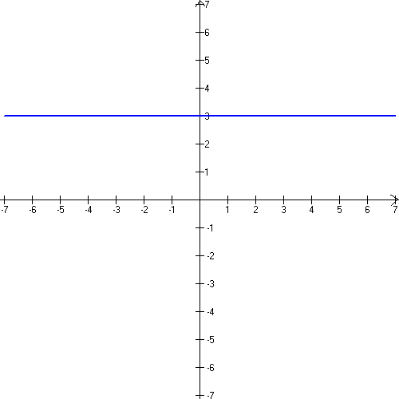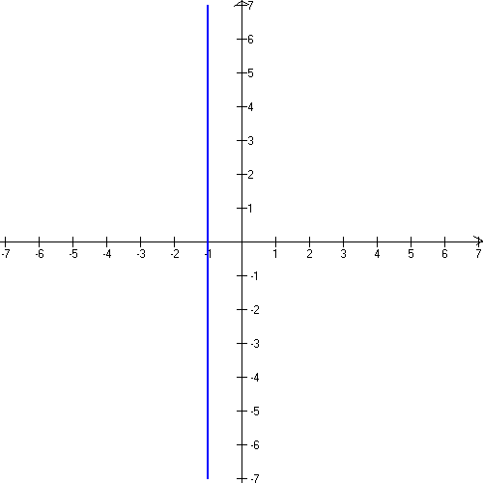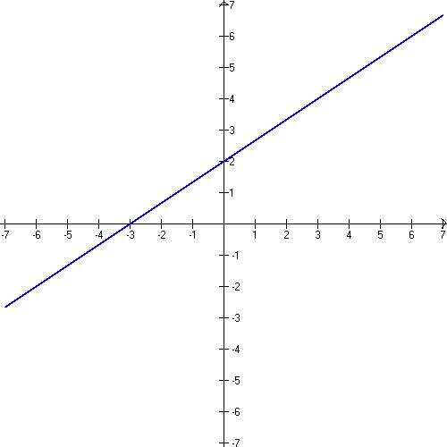
22. The equation of a line L is 3x + 5y -10 = 0. Find the slope of a line that is
a) parallel to L
b) perpendicular to L
23. Find the equation for the line with given properties. Express your answer in the slope-intercept form.
a) parallel to the line 2x + y = 5; containing the point (2, - 1)
b) perpendicular to the line y = 2x + 4; containing the point (2, -1)
c) parallel to the line x = -2; containing the point (3, -1)
d) perpendicular to the line y = 3; containing the point (0,1).
24. Determine whether the lines 2x +3y = -3 and 3x + 2y = 10 are parallel, perpendicular or neither. Explain.

